**VISUALIZATION TOOL FOR ELECTRIC VEHICLE CHARGE AND RANGE ANALYSIS**

**1.INTRODUCTION**

* 1. **Overview :**

Electric vehicles (EVs) are a promising technology for achieving a sustainable transport sector in the future, due to their very low to zero carbon emissions, low noise, high efficiency, and flexibility in grid operation and integration. Different types of electric-drive vehicles are presented. These include battery electric vehicles, plug-in hybrid electric vehicles, hybrid electric vehicles and fuel cell electric vehicles. The topologies for each category and the enabling technologies are discussed. Various power train configurations, new battery technologies, and different charger converter topologies are introduced. Electrifying transportation not only facilitates a clean energy transition, but also enables the diversification of transportation’s sector fuel mix and addresses energy security concerns. In addition, this can be also seen as a viable solution, in order to alleviate issues associated with climate change. Furthermore, charging standards and mechanisms and relative impacts to the grid from charging vehicles are also presented.

* 1. **Purpose :**

By this project, we can know the following data's…

1. Charging an electric vehicle is cheaper than filling petrol or diesel.
2. It reduce vehicular emission and air pollution levels within the country.
3. Lower maintenance due to an efficient electric motor.
4. Better performance for use.
5. Tax and financial benefits.

**2.PROBLEM DEFINITION & DESIGN THINKING**

**2.1.Empathy map :**

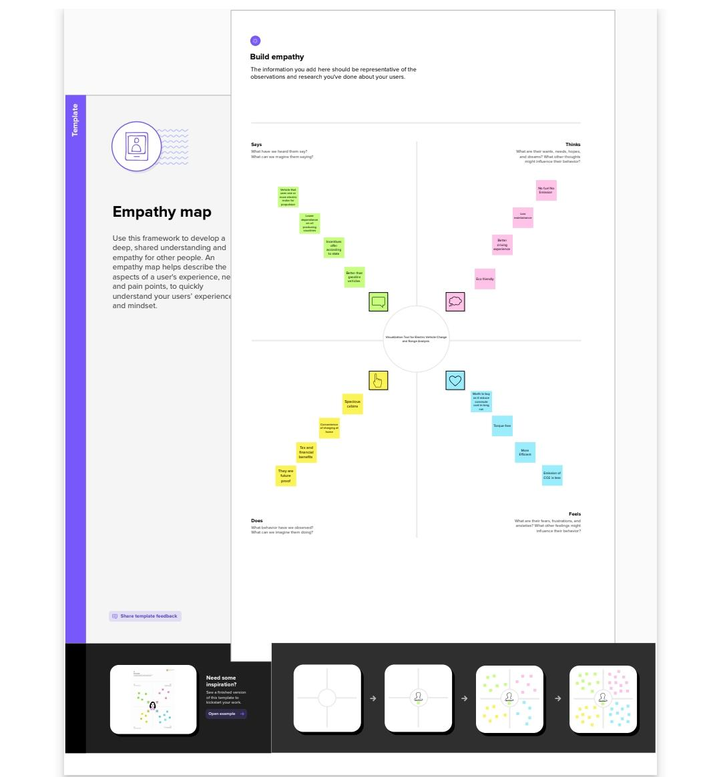

**2.2.Ideation & Brainstorming map**

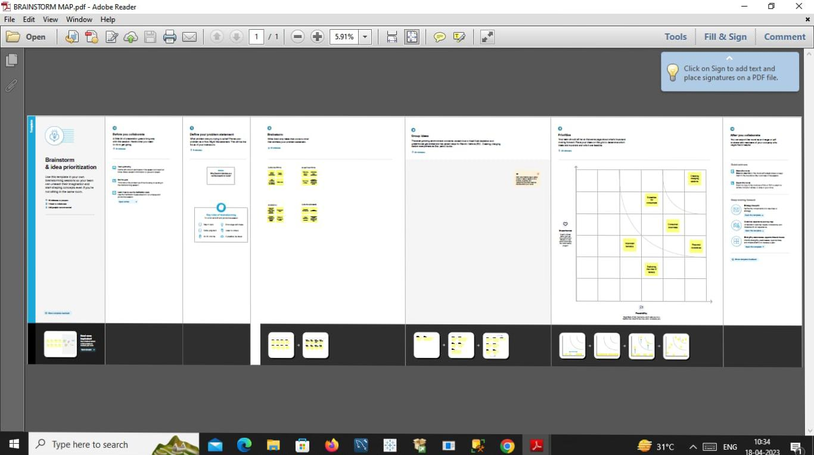

**3.RESULT**

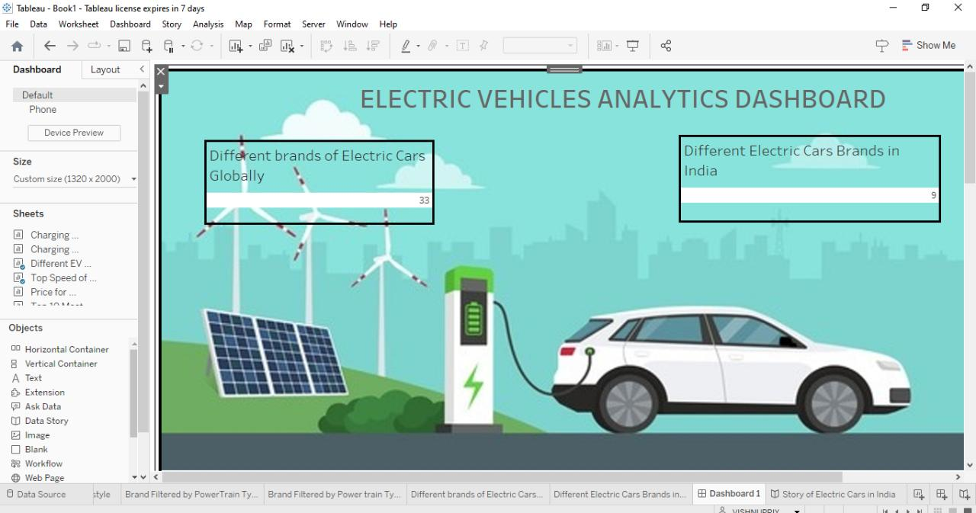

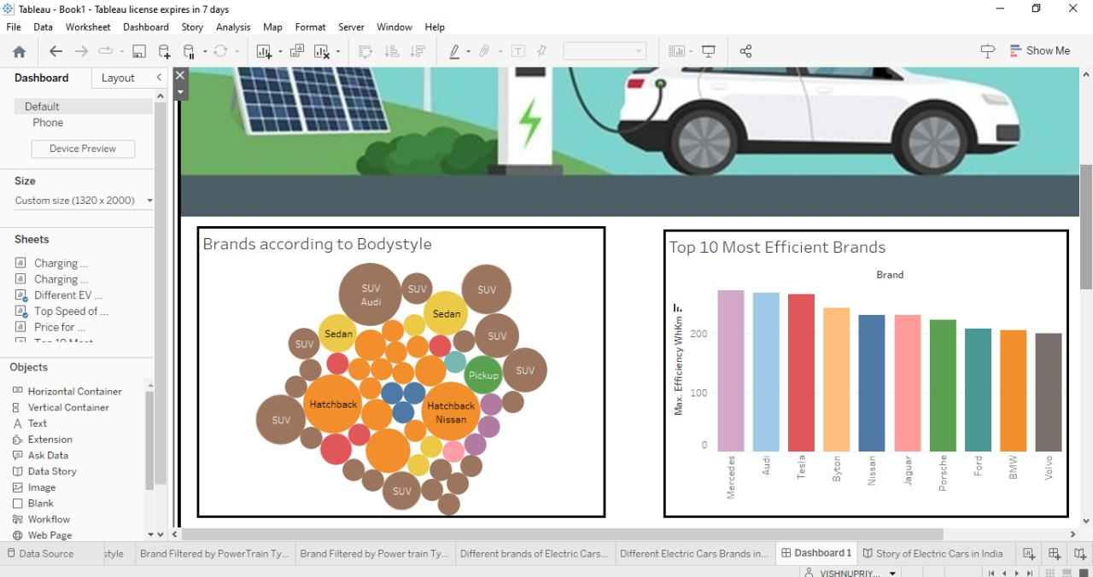

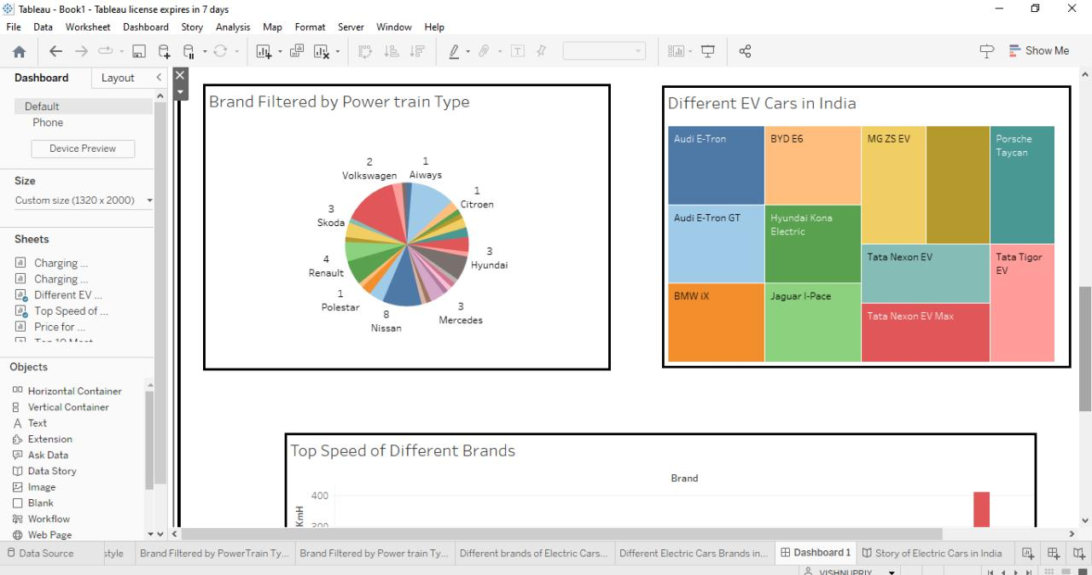

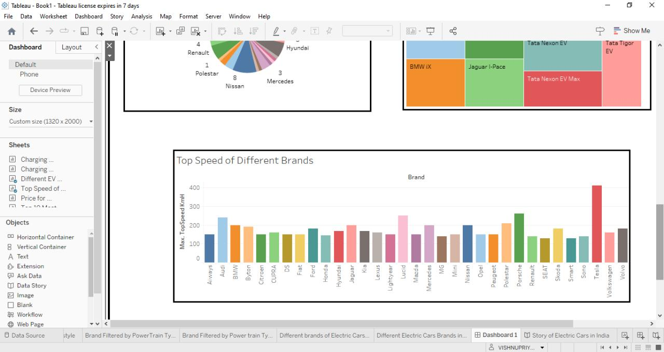

**4.ADVANTAGES & DISADVANTAGES**

**4.1.Avantages :**

* Eco-friendly, it run on renewable energy source.
* Electric vehicles are easy to drive and quiet.
* Lower dependence on oil producing countries.
* Convenience of charging at home.
* Government incentives.
* Running on electricity means good bye to exhaust gases.

**4.2.Disadvantages :**

* It might take large time to charge.
* It might be difficult to locate the station.

**5.APPLICATIONS**

It is used in the electric motors, batteries, inverters, wiring and in charging stations because of its durability, malleability, reliability and superior electrical conductivity.

**6.CONCLUSION**

In this analysis we analysed, the top speed of different brand is Tesla, the top most efficient brand is Mercedes, Audi- E. Tron is a five seat up car with 400 km range and 119.0 price range lakh, The different brand in electric cars globally is 33, there are totally 9 electric cars brands in India.

**7.FUTURE SCOPE**

Many nations are working to free mother earth from the clutches of carbon emissions and CO2 , India should take the lead by transitioning to EV mobility, making the country a greener and cleaner ecosystem.

“ EV ARE THE FUTURE”

**8.APPENDIX**